Mecca Agreement (Security) Est 2026

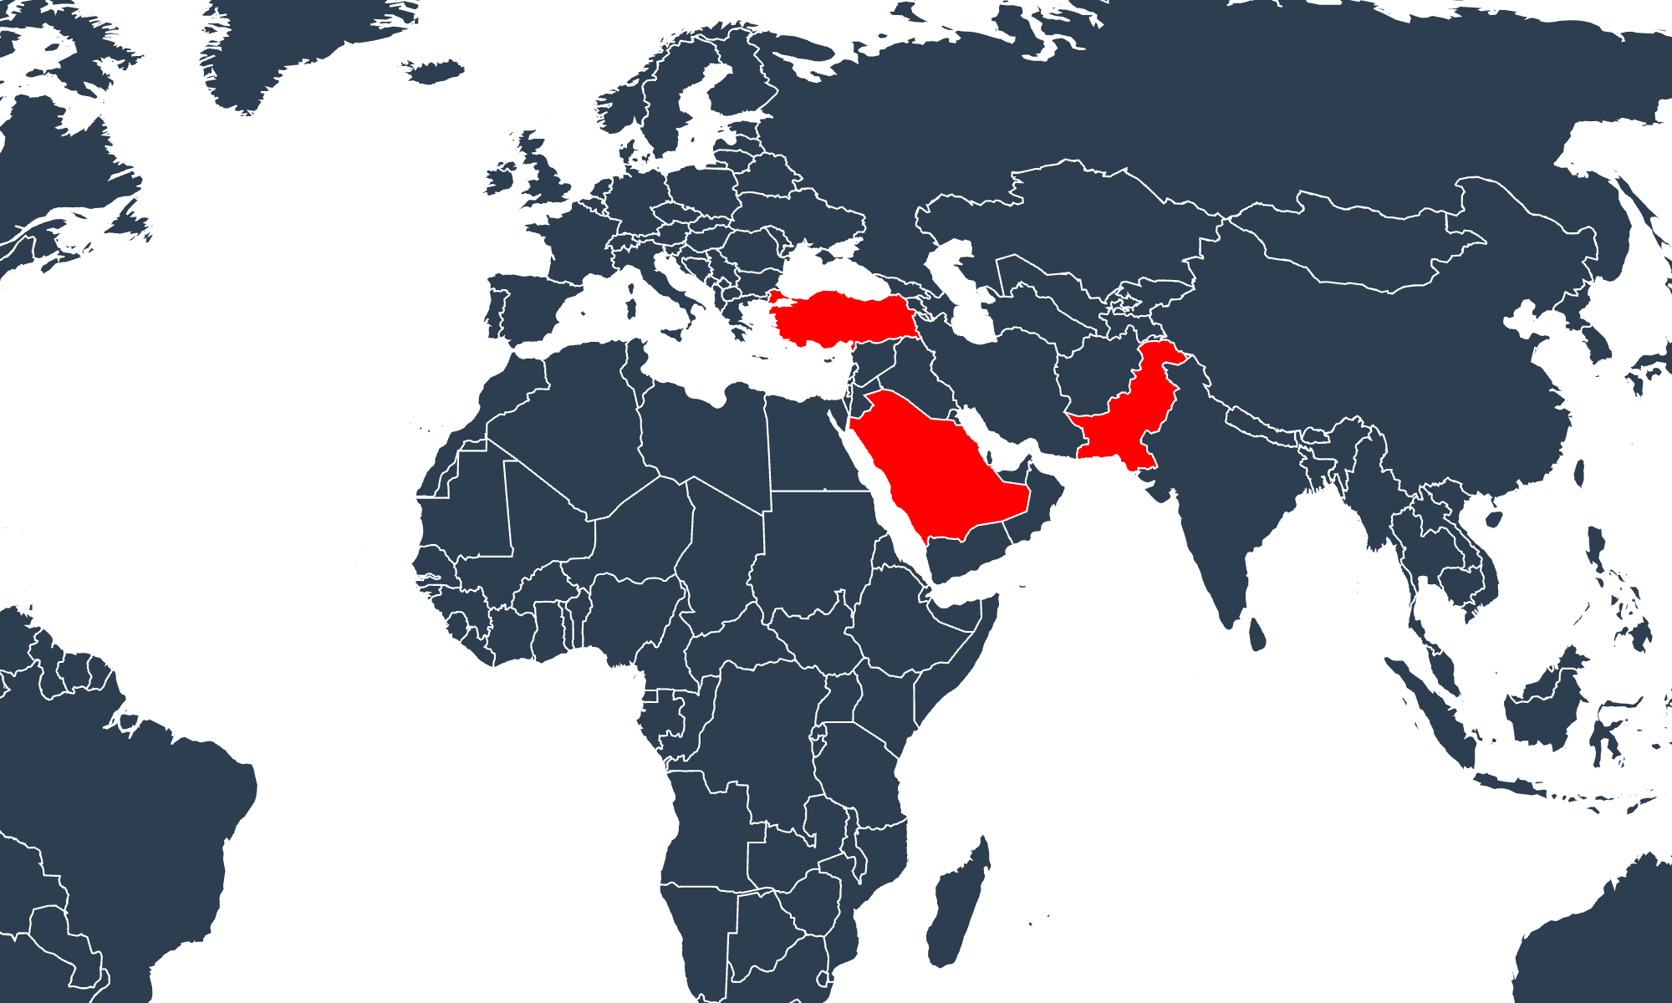

Five Eyes (Intelligence) Est 1943

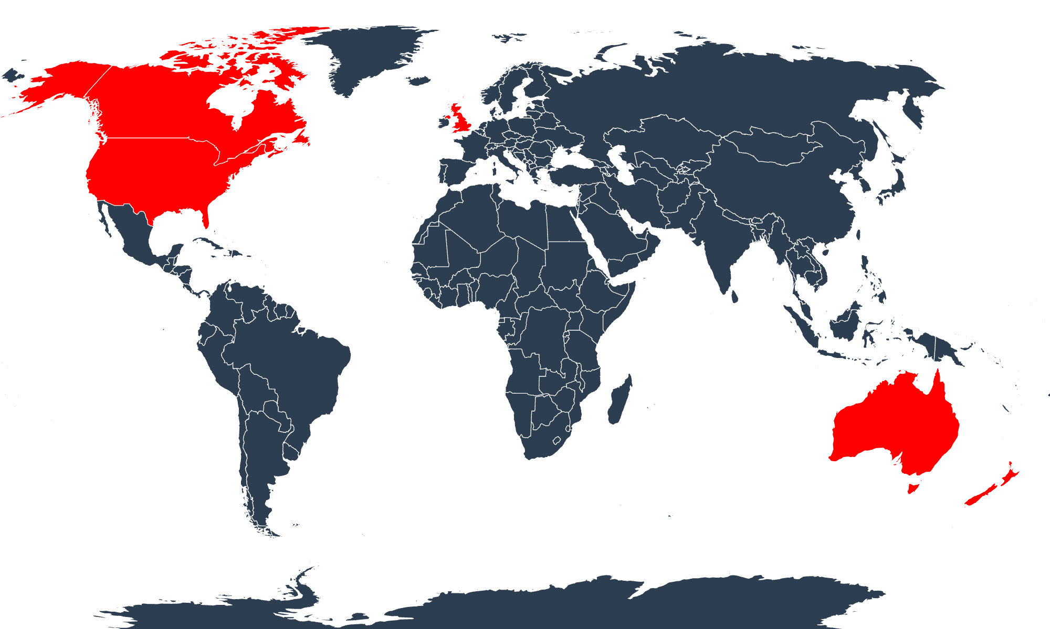
BRICS (Economic) Est 2009

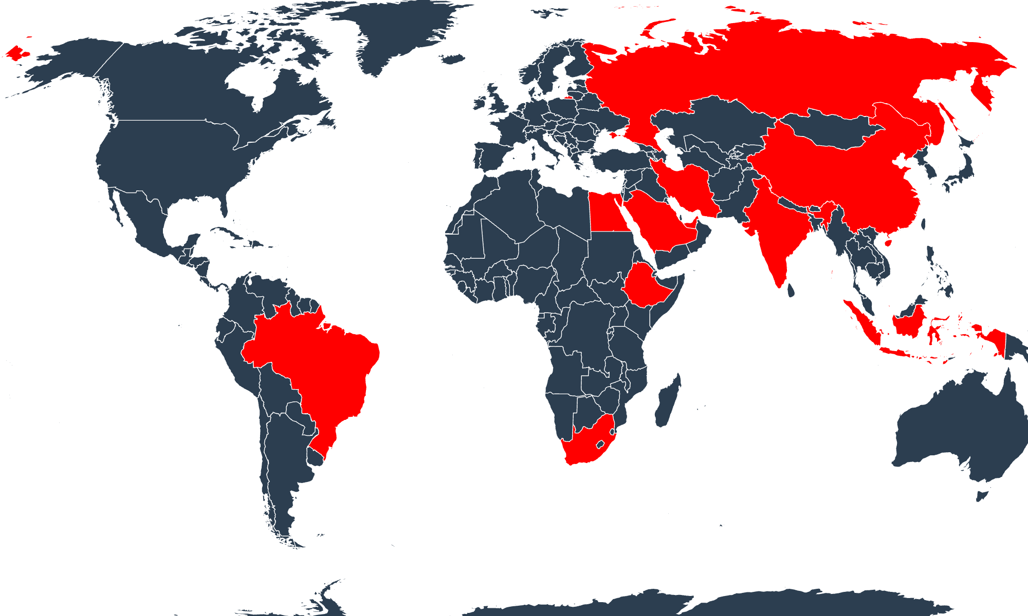

Trans-Pacific (Economic) Est 2016

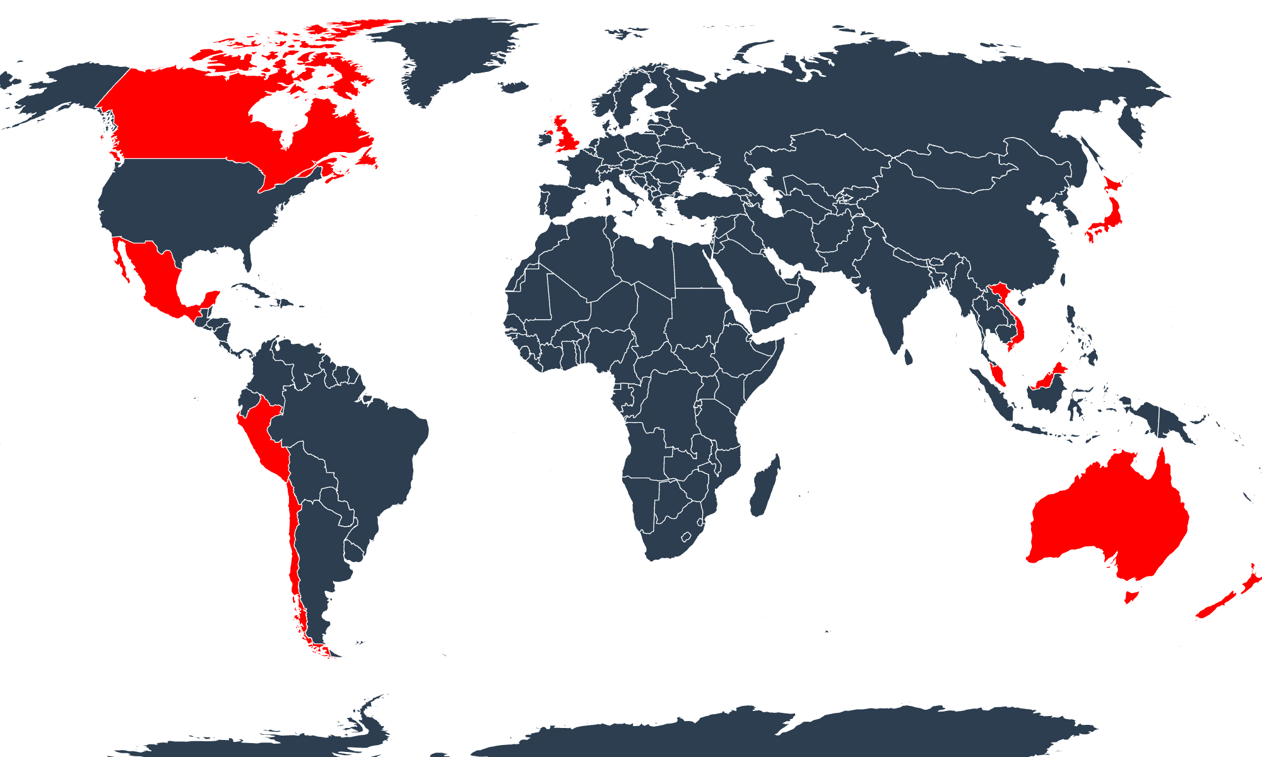
ASEAN (Cooperation) Est 1967

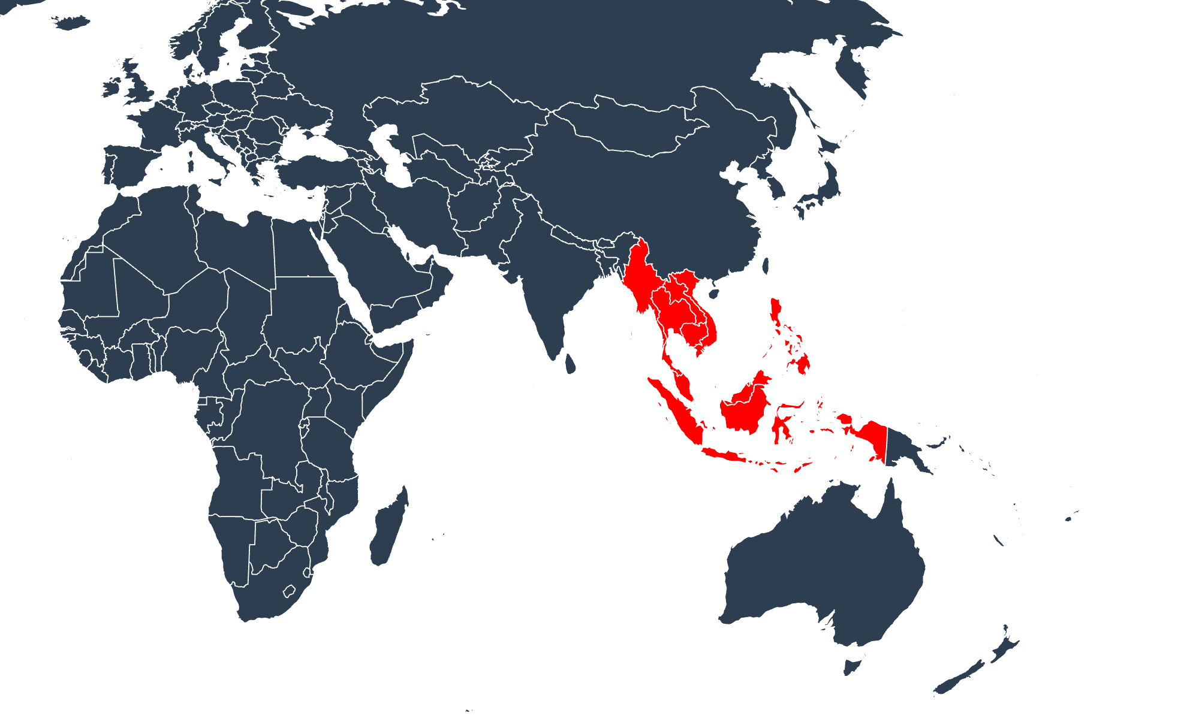

EU (Political-Economic) Est 1993

